**AZ-900 Domain Area**

**Weight**

Describe cloud concepts 20-25%

Describe core Azure services 15-20%

Describe core solutions and management tools on Azure 10-15%

Describe general security and network security features 10-15%

Describe identity, governance, privacy, and compliance features 20-25%

Describe Azure cost management and Service Level Agreements 10-15%

**Azure Fundamentals part 1: Describe core Azure concepts**

* Understand the benefits of cloud computing in Azure and how it can save you time and money
* Explain cloud concepts such as high availability, scalability, elasticity, agility, and disaster recovery
* Describe core Azure architecture components such as subscriptions, management groups, resources and resource groups
* Summarize geographic distribution concepts such as Azure regions, region pairs, and availability zones

1. Azure is a cloud computing platform with an ever-expanding set of services to help you build solutions to meet your business goals
2. Azure services:
   1. Simple web services for hosting your business presence in the cloud
   2. Fully virtualized computers for you to run your custom software solutions
3. Cloud-based services:
   1. remote storage
   2. database hosting
   3. centralized account management
4. Azure also offers new capabilities like AI and Internet of Things (IoT)

# What is cloud computing?

1. Delivery of computing services over the internet
2. These services include servers, storage, databases, networking, software, analytics, and intelligence
3. Cloud computing offers faster innovation, flexible resources, and economies of scale
4. PC is in the cloud, you pay for what you need.
5. Add and remove compute power as needed. Saves on cost.
6. Always on-line.

# Why is cloud computing typically cheaper to use?

1. Pay-as-you-go pricing model
2. Helps you:
   1. Lower your operating costs.
   2. Run your infrastructure more efficiently
   3. Scale as your business needs change
3. Rent compute power and storage from someone else's datacentre
4. You're billed only for what you use
5. Instead of maintaining CPUs and storage in your datacenter, you rent them for the time that you need them
6. Provider maintains the underlying infrastructure for you

# Why should I move to the cloud?

1. Helps you move faster and innovate
2. In our ever-changing digital world, two trends emerge:
   1. Teams deliver new features to their users at record speeds
   2. Users expect an increasingly rich and immersive experience with their devices and with software
3. Software not released in months but rather weeks.
4. Releases in small batches
5. Even multiple releases in a day?
6. The cloud provides on-demand access to:
   1. Limitless pool of raw compute, storage, and networking components
   2. Speech recognition and other cognitive services
   3. Analytics services that deliver telemetry data

# What is Azure?

1. Continually expanding set of cloud services
2. Help your organization meet your current and future business challenges
3. Gives you the freedom to build, manage, and deploy applications on a massive global network using your favourite tools and frameworks

# What does Azure offer?

1. Benefits that Azure provides, so you can easily invent with purpose:
   1. **Be ready for the future:** Continuous innovation for today and future
   2. **Build on your terms:**  You can build how you want and deploy where you want to
   3. **Operate hybrid seamlessly:** Tools and services for a hybrid cloud solution
   4. **Trust your cloud:** Get security, backed experts, and proactive compliance trusted by many.

# What can I do with Azure?

1. Provides more than 100 services
2. Move existing applications to virtual machines that run in Azure
3. Azure provides AI and machine-learning services that can naturally communicate with your users through vision, hearing, and speech
4. Storage solutions that dynamically grow
5. Uses a technology called Virtualization – Separates tight coupling between hardware and operating system
6. Uses an abstraction layer called a Hypervisor
7. Each server has a hypervisor to run virtual machines
8. Each server also runs a fabric controller.
9. Also connected to an Orchestrator – manages everything that happens in Azure. Including handling user requests.
10. User make requests through Orchestrators Web Api. Can be called from the Azure Portal.

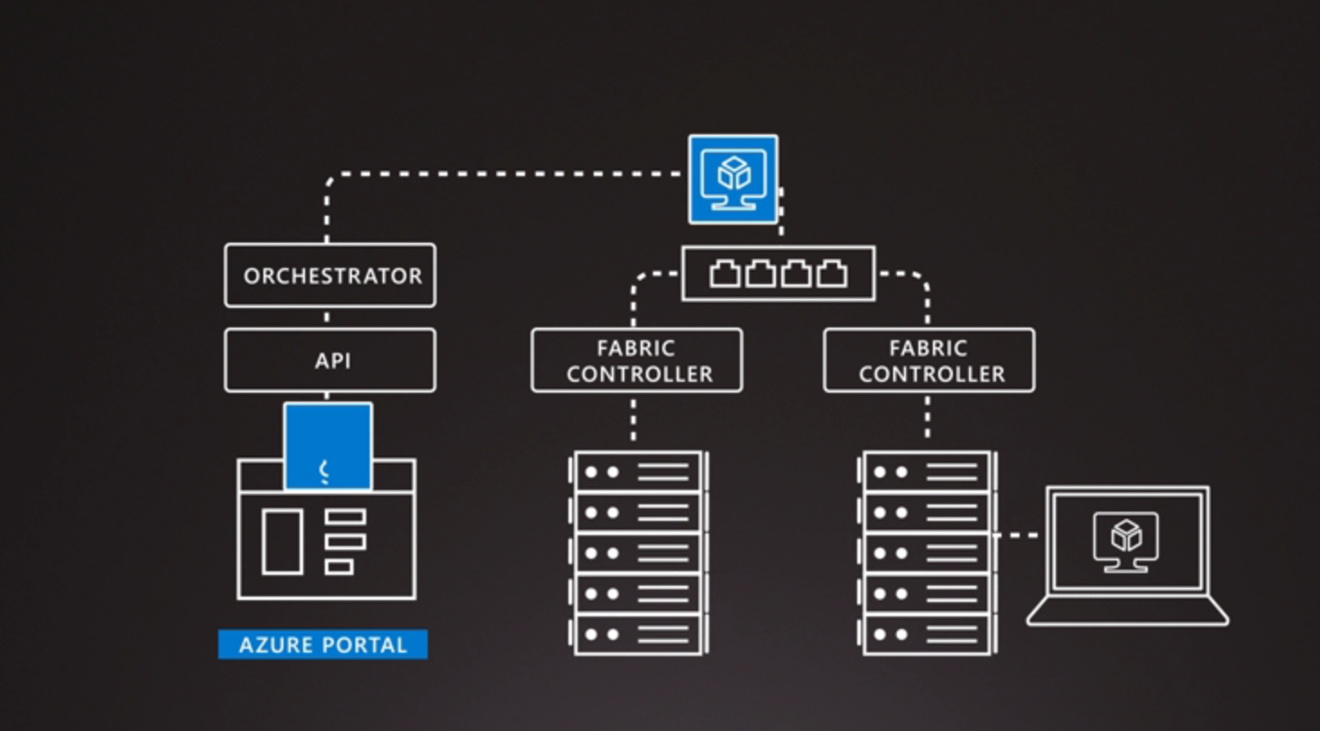

# What is the Azure portal?

1. A web-based, unified console that provides an alternative to command-line tools
2. Can manage your Azure subscription by using a graphical user interface
3. You can:
4. Build, manage, and monitor simple web apps to complex deployments.
5. Create custom dashboards for an organized view of resources.
6. Configure accessibility options for an optimal experience.
7. Designed for resiliency and continuous availability
8. Avoids network slowdowns by being close to users

# What is Azure Marketplace?

1. Helps connect users with Microsoft partners, independent software vendors, and startups that are offering their solutions and services
2. Customers can find, try, purchase, and provision applications and services from hundreds of leading service providers
3. Provision end-to-end solutions quickly and reliably, hosted in your own Azure environment
4. At the time of writing, there are more than 8,000 listings

# Azure Services

1. Azure brings a massive global infrastructure that's always available for you to build your applications on.
2. Services:
   1. **Compute**: Scale on demand. Pay for what you use. Use VM or scale for mobile.
   2. **Networking**: Connection. Using VPN and Load Balancing
   3. **Storage**: Disk, File, Blog or Archival storage. Scale as needed in a secure fashion.
   4. **Mobile**: Build and deploy cross platform and native apps. Send notifications and use Xamarin. Take advantage of cognitive services.
   5. **Databases**: Use a variety of DBs including open source. SQL, Cosmos DB and MySQL
   6. **Web**: Build, develop and scale web apps. Create web apps, api and use Azure Maps geo-spatial contexts.
   7. **IoT**: Analyse data from sensors.
   8. **Big Data**: Open source cluster services to help make decisions
   9. **AI**: Use data to forecast future behaviours. Use machine learning for deployment
   10. **DevOps**: Brings together people, processes and technology by automating software delivery. Create and deliver release pipelines
   11. For more: <https://docs.microsoft.com/en-us/learn/modules/intro-to-azure-fundamentals/tour-of-azure-services>
3. Services:
   1. **Compute**: Azure Virtual Machines, Azure Virtual Machine Scale Sets, Azure Kubernetes Service, Azure Service Fabric, Azure Batch, Azure Container Instances, Azure Functions
   2. **Networking**: Azure Virtual Network, Azure Load Balancer, Azure Application Gateway, Azure VPN Gateway, Azure DNS, Azure Content Delivery Network, Azure DDoS Protection, Azure Traffic Manager, Azure ExpressRoute, Azure Network Watcher, Azure Firewall, Azure Virtual WAN
   3. **Storage**: Azure Blob storage, Azure File storage, Azure Queue storage, Azure Table storage. These services all share several common characteristics:
      1. **Durable**
      2. **Secure**
      3. **Scalable**
      4. **Managed**
      5. **Accessible**
   4. **Mobile**: back-end services for iOS, Android, and Windows apps quickly and easily. Use resources such as SAP, Oracle, SQL Server, and SharePoint. Other features of this service include:
   5. **Databases**: Azure Cosmos DB, Azure SQL Database, Azure Database for MySQL, Azure Database for PostgreSQL, SQL Server on Azure Virtual Machines, Azure Synapse Analytics, Azure Database Migration Service, Azure Cache for Redis, Azure Database for MariaDB.
   6. **Web**: Azure App Service, Azure Notification Hubs, Azure API Management, Azure Cognitive Search, Web Apps feature of Azure App Service, Azure SignalR Service
   7. **IoT**: IoT Central, Azure IoT Hub, IoT Edge
   8. **Big Data**: Azure Synapse Analytics, Azure HDInsight, Azure Databricks
   9. **AI**: Azure Machine Learning Service, Azure ML Studio
      1. cognitive services:
         1. Vision
         2. Speech
         3. Knowledge mapping
         4. Bing Search
         5. Natural Language processing
   10. **DevOps**: Azure DevOps, Azure DevTest Labs

# Get started with Azure accounts

1. You need an Azure subscription
2. Learners can use learn sandbox
3. Azure account, and a subscription
4. After you've created an Azure subscription, you can start creating Azure resources within each subscription.

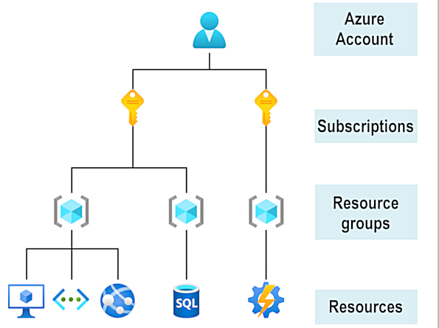

# Create an Azure account

1. You can purchase Azure access from Microsoft by signing up on the [Azure website](https://azure.microsoft.com/) or through a Microsoft representative
2. You can also purchase Azure access through a Microsoft partner
3. Cloud Solution Provider partners offer a range of complete managed-cloud solutions for Azure.

# Free Account

* Free access to certain Azure services for 12 months.
* A credit to use in the first 12 months.
* Free access to certain software developer tools.

# What is the Learn sandbox?

1. Learn exercises use a technology called the sandbox,
2. Learn automatically cleans up the temporary resources for you after you've completed the module

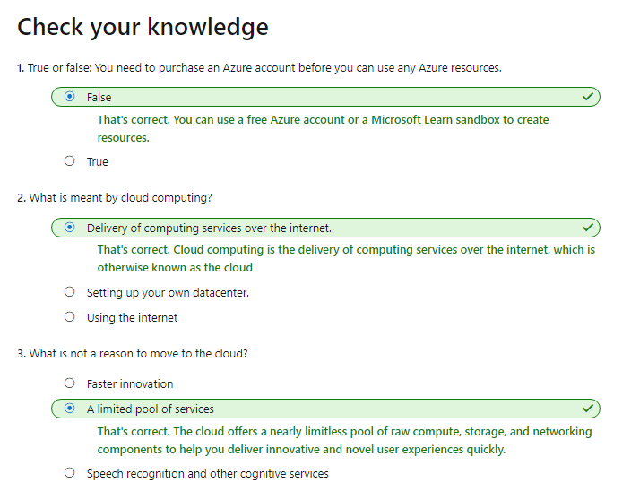

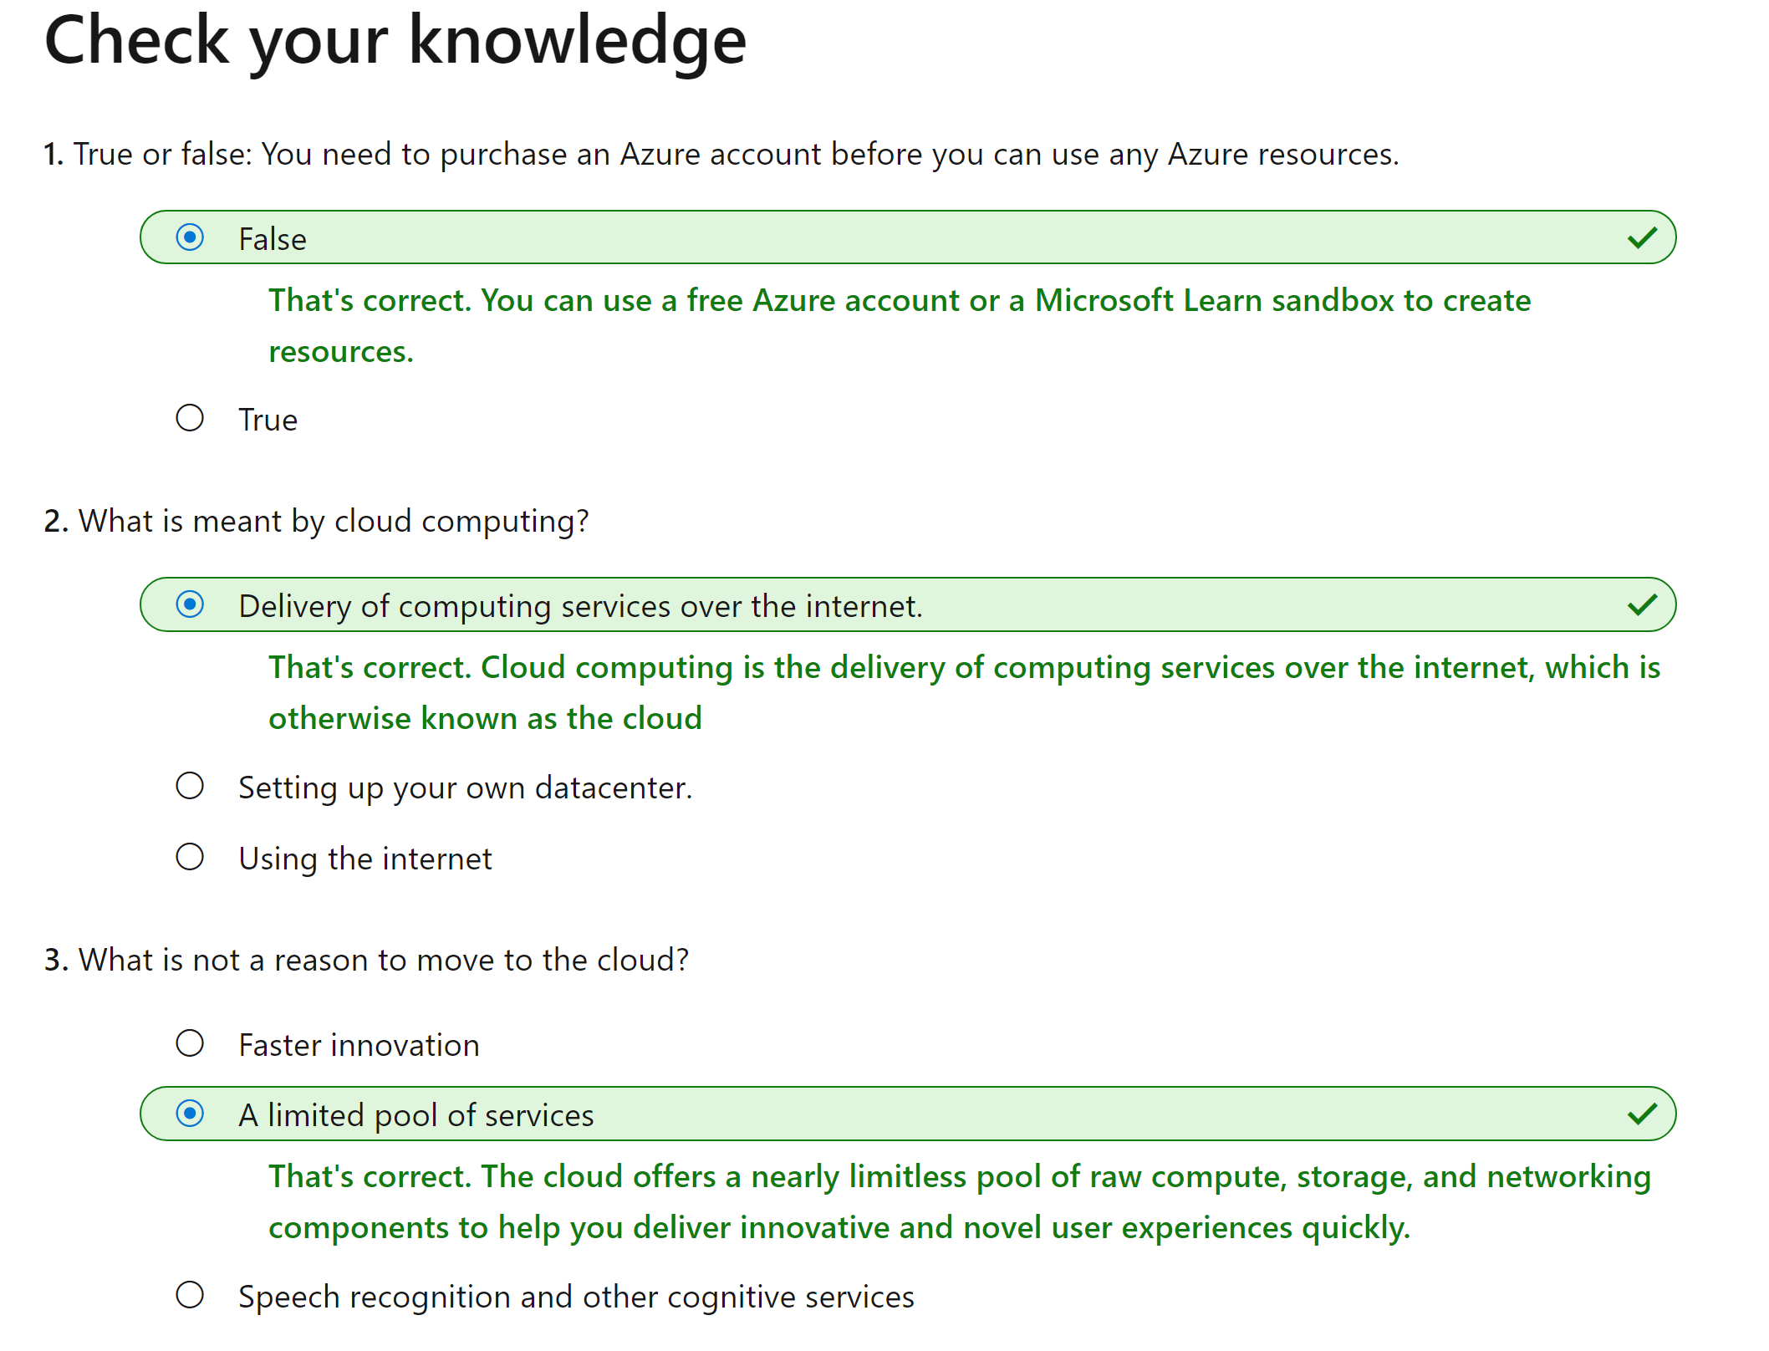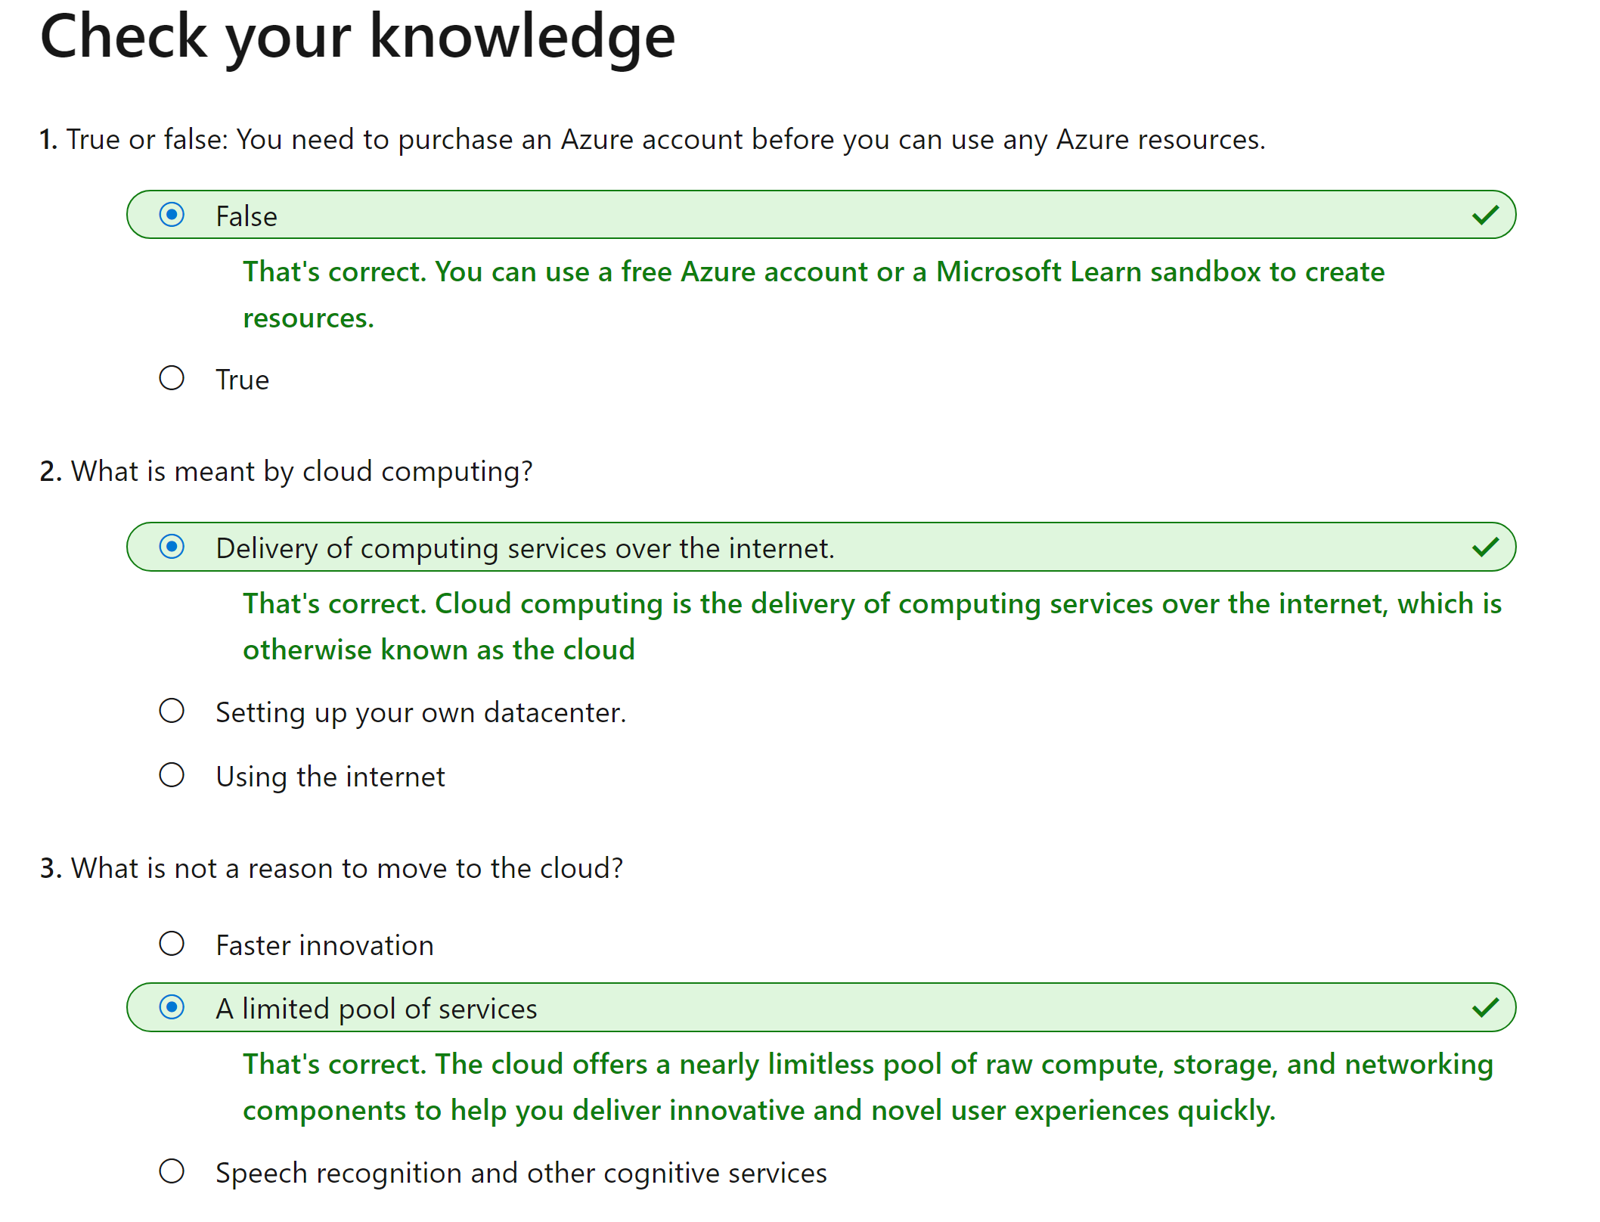Bottom of Form

# What are public, private, and hybrid clouds?

### **Public cloud**

* No capital expenditures to scale up.
* Applications can be quickly provisioned and deprovisioned.
* Organizations pay only for what they use.

### **Private cloud**

* Hardware must be purchased for start-up and maintenance.
* Organizations have complete control over resources and security.
* Organizations are responsible for hardware maintenance and updates.

### **Hybrid cloud**

* Provides the most flexibility.
* Organizations determine where to run their applications.
* Organizations control security, compliance, or legal requirements.

# What are some cloud computing advantages?

1. **High availability:** Depending on the service-level agreement (SLA)
2. **Scalability**
   1. Scale vertically - increase compute capacity by adding RAM or CPUs
   2. Scaling horizontally -  adding VMs to the configuration
3. **Elasticity**
   1. *Auto scaling*, so your apps always have the resources they need.
4. **Agility:** Deploy and configure cloud-based resources quickly
5. **Geo-distribution**
6. **Disaster recovery**

# Capital expenses vs. operating expenses

1. **Capital Expenditure (CapEx)** - up-front spending of money on physical infrastructure, and then deducting that up-front expense over time. The up-front cost from CapEx has a value that reduces over time.
2. **Operational Expenditure (OpEx):** spending money on services or products now, and being billed for them now. There is no up-front cost, as you pay for a service or product as you use it.

Cloud services, on the other hand, are categorized as an OpEx, because of their consumption model.  As a result, OpEx has a direct impact on net profit, taxable income, and the associated expenses on the balance sheet.

# Cloud computing is a consumption-based model

1. Consumption-based model, which means that end users only pay for the resources that they use
2. A consumption-based model has many benefits:
   1. No upfront costs.
   2. No need to purchase and manage costly infrastructure
   3. Pay for additional resources when they are needed
   4. Ability to stop paying for resources

# What are cloud service models?

1. These models define the different levels of shared responsibility that a cloud provider and cloud tenant are responsible for.
2. **IaaS - C**loud provider will keep the hardware up-to-date. Operating system maintenance and network configuration is up to you. E.g Azure Virtual Machines.
3. **PaaS -** Managed hosting environment. Cloud provider manages the virtual machines and networking resources. Tenant deploys their applications into the managed hosting environment. E.g Azure App Services – Developers can upload applications without worrying about physical hardware.
4. **SaaS -** Cloud provider manages all aspects of the application environment. Such as virtual machines, networking resources, data storage, and applications. Tenant only needs to provide their data to the application managed by the cloud provider. For example Microsoft Office 365.

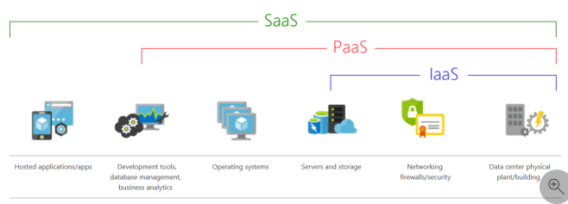

# IaaS

1. The most flexible category of cloud services
2. Gives you complete control over the hardware that runs your application. Instead of buying hardware, with IaaS, you rent it.
3. **Advantages: No CapEx, Agility, Management, Consumption-based model, Skills, Cloud benefits, Flexibility.**

# PaaS

1. Same benefits and considerations as IaaS
2. **Advantages: No CapEx, Agility, Consumption-based model, Skills, Cloud benefits, Productivity**
3. **Disadvantage:** **Platform limitations -** Limitations to a cloud platform that might affect how an application runs

# SaaS

1. Software that's centrally hosted and managed for you and your users or customers
2. Licensed through a monthly or annual subscription
3. SaaS provides the same benefits as IaaS
4. **Advantages: No CapEx, Agility, Pay-as-you-go pricing model, Skills, Flexibility**
5. **Flexibility: Software limitations -** Affect how users work, you don't have direct control of features. When you're evaluating which SaaS platform is best suited for a workload, be sure to consider any business needs and software limitations.

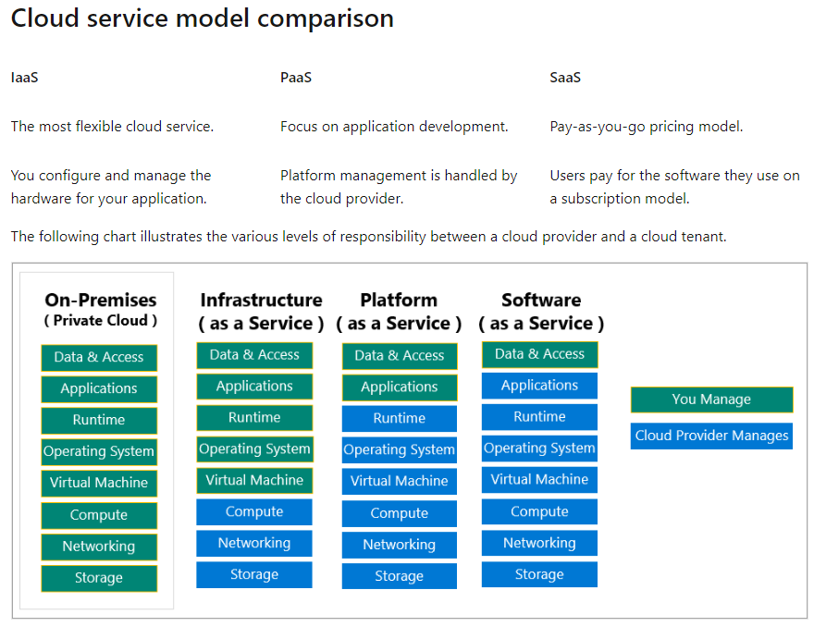

# What is serverless computing?

1. Like PaaS, serverless computing enables developers to build applications faster by eliminating the need for them to manage infrastructure
2. Cloud service provider automatically provisions, scales, and manages the infrastructure required to run the code
3. Serverless architectures are highly scalable and event-driven, only using resources when a specific function or trigger occurs.
4. "Serverless" name comes from the fact that the tasks associated with infrastructure provisioning and management are invisible to the developer.
5. This approach enables developers to increase focus on the business logic, and deliver more value
6. Helps teams increase their productivity and bring products to market faster

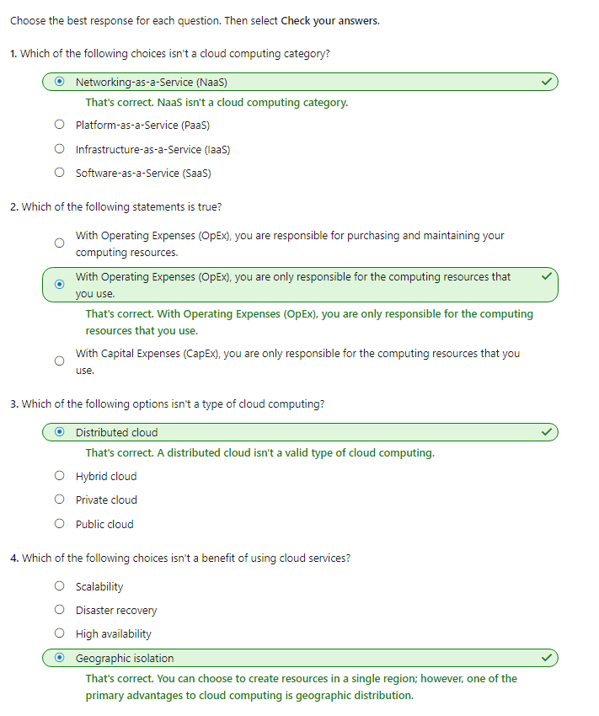

# Overview of Azure subscriptions, management groups, and resources

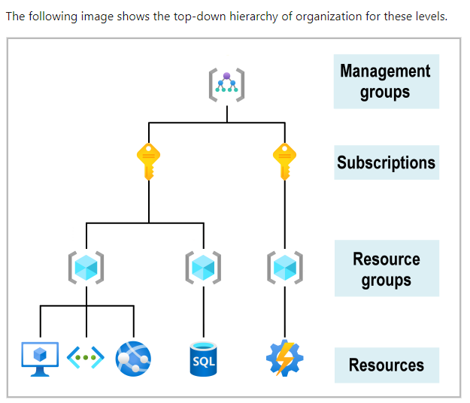

1. **Resources:** Are instances of services like  virtual machines, storage, or SQL databases
2. **Resource groups:** Logical container into which Azure resources like web apps, databases, and storage accounts are deployed and managed
3. **Subscriptions:** Groups together user accounts and the resources. For each subscription, there are limits or quotas on the amount of resources that you can create and use.
4. **Management groups:** Helps you manage access, policy, and compliance for multiple subscriptions.  All subscriptions in a management group automatically inherit the conditions applied to the management group.

# Azure regions, availability zones, and region pairs

1. Resources are created in regions, which are different geographical locations around the globe that contain Azure datacenters
2. When you use a service or create a resource such as a SQL database or virtual machine (VM), you're using physical equipment in one or more of these locations

# Azure regions

1. A region is a geographical area on the planet with multiple datacenters that are nearby and networked together with a low-latency network
2. When you deploy a resource in Azure, you'll often need to choose the region
3. Some services or VM features are only available in certain regions, such as VM sizes.
4. Global Azure services that don't require you to select a particular region: Azure Active Directory, Azure Traffic Manager, and Azure DNS

# Why are regions important?

1. Global regions provide better scalability and redundancy
2. They also preserve data residency for your services

# Special Azure regions

1. **US DoD Central, US Gov Virginia, US Gov Iowa and more:**
2. **China East, China North, and more:** partnership between Microsoft and 21Vianet, whereby Microsoft doesn't directly maintain the datacenters

# Azure availability zones

1. Ensure your services and data are redundant so you can protect your information in case of failure
2. Azure can help make your app highly available through availability zones

# What is an availability zone?

1. Availability zones are physically separate datacenters within an Azure region
2. Availability zone is made up of one or more datacenters equipped with independent power, cooling, and networking
3. An availability zone is set up to be an isolation boundary
4. If one zone goes down, the other continues working

# Use availability zones in your apps

1. Use availability zones to run mission-critical applications and build high-availability into your application
2. Co-locating your compute, storage, networking, and data resources within a zone and replicating in other zones
3. Cost to duplicating your services and transferring to zones.
4. Azure services that support availability zones fall into two categories:
   1. **Zonal services**
   2. **Zone-redundant services**

# Azure region pairs

1. An outage big enough to affect even two datacenters. That's why Azure also creates region pairs.

# What is a region pair?

1. Each Azure region is always paired with another region within the same geography (such as US, Europe, or Asia) at least 300 miles away
2. Approach allows for the replication of resources
3. Reduce the likelihood of interruptions because of events such as natural disasters, civil unrest, power outages, or physical network outages
4. **Additional advantages of region pairs:** Restored as quickly as possible for applications hosted in that region pair, Updates are rolled out one region at a time to minimize downtime, Data continues to reside within the same geography as its pair for law-enforcement jurisdiction purposes

# Azure resources and Azure Resource Manager

1. After you've created a subscription you're ready to start creating resources and storing them in resource groups
2. It's important to define those terms:
   1. **Resource:** Virtual machines (VMs), storage accounts, web apps, databases, and virtual networks are examples
   2. **Resource group:** A container that holds related resources for an Azure solution

# Azure resource groups

1. A resource group is a logical container for resources deployed on Azure
2. Resources are anything you create in an Azure subscription like VMs, Azure Application Gateway instances, and Azure Cosmos DB instances
3. Resource can only be a member of a single resource group.
4. Many resources can be moved between resource groups
5. Resource groups can't be nested
6. Before any resource can be provisioned, you need a resource group for it to be placed in

# Life cycle

1. If you delete a resource group, all resources contained within it are also deleted

# Authorization

1. Resource groups are also a scope for applying role-based access control (RBAC) permission

# Azure Resource Manager

1. Azure Resource Manager is the deployment and management service
2. It provides a management layer that enables you to create, update, and delete resources
3. Features like access control, locks, and tags to secure and organize your resources after deployment
4. When a user sends a request from any of the Azure tools, APIs, or SDKs, Resource Manager receives the request. It authenticates and authorizes the request
5. Resource Manager sends the request to the Azure service, which takes the requested action
6. 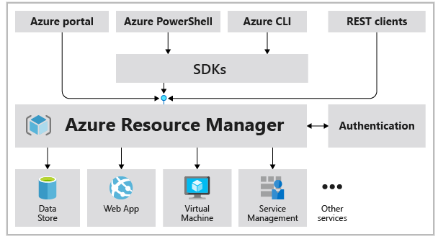Because all requests are handled through the same API, you see consistent results

# The benefits of using Resource Manager

1. Manage your infrastructure through declarative templates rather than scripts. Resource Manager Template is a JSON file.
2. Deploy, manage, and monitor all the resources for your solution as a group, rather than handling these resources individually.
3. Redeploy your solution throughout the development life cycle and have confidence your resources are deployed in a consistent state.
4. Define the dependencies between resources
5. Apply access control to all services
6. Apply tags to resources to logically organize
7. Clarify your organization's billing by viewing costs for a group of resources

# Azure subscriptions

1. Using Azure requires an Azure subscription
2. Subscription provides you with authenticated and authorized access to Azure products and services
3. Allows you to provision resources
4. Azure subscription is a logical unit of Azure services that links to an Azure account which is an identity in Azure Active Directory (Azure AD)

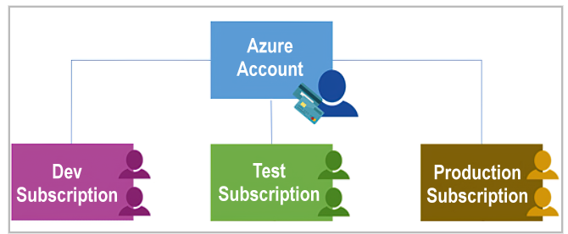

1. An account can have one subscription or multiple subscriptions that have different billing models
2. There are two types of subscription boundaries that you can use:
   1. **Billing boundary**: This subscription type determines how an Azure account is billed
   2. **Access control boundary**: You have different departments to which you apply distinct Azure subscription policies

# Create additional Azure subscriptions

1. You might choose to create additional subscriptions to separate:
   1. **Environments:** Set up separate environments for development and testing, security, or to isolate data for compliance reasons
   2. **Organizational structures:** create subscriptions to reflect different organizational structures. For example lower cost resources
   3. **Billing:** You might want to also create additional subscriptions for billing purposes.
   4. **Subscription limits:**  Subscriptions are bound to some hard limitations

# Customize billing to meet your needs

1. If you have multiple subscriptions, you can organize them into invoice sections
2. You might need a single invoice for your organization but want to organize charges by department, team, or project
3. You can set up multiple invoices within the same billing account
4. Each billing profile has its own monthly invoice

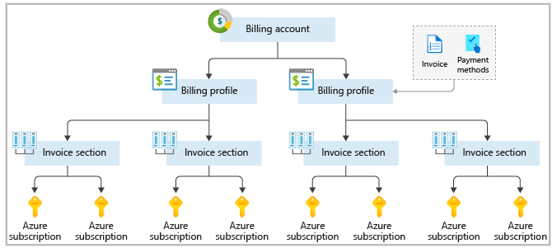

# Azure management groups

1. Azure management groups provide a level of scope above subscriptions
2. You organize subscriptions into containers called management groups and apply your governance conditions to the management groups
3. All subscriptions within a management group automatically inherit the conditions applied to the management group
4. All subscriptions within must trust the same Azure AD tenant.

# Hierarchy of management groups and subscriptions

1. The following diagram shows an example of creating a hierarchy for governance by using management groups:

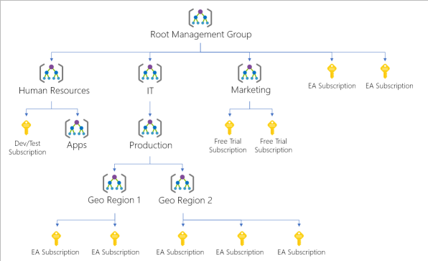

1. Important facts about management groups:
   1. 10,000 management groups can be supported in a single directory
   2. A management group tree can support up to six levels of depth
   3. Each management group and subscription can support only one parent
   4. Each management group can have many children.
   5. All subscriptions and management groups are within a single hierarchy in each directory.

# AZURE EXERCISE

# What is App Service?

1. HTTP-based service that enables you to build and host many types of web-based solutions without managing infrastructure
2. For example, you can host web apps, mobile back ends, and RESTful APIs in several supported programming languages.
3. .NET, .NET Core, Java, Ruby, Node.js, PHP, or Python can run in and scale with ease on both Windows-based and Linux-based environments

# What is Azure Marketplace?

1. Online store that hosts applications
2. Many types of applications are available, ranging from AI and machine learning to web application

# Create resources in Azure

1. First thing we'd do is to create a resource group
2. The resource group enables us to administer all the services, disks, network interfaces, and other elements
3. We can use the Azure portal to create and manage
4. Can also use command line by using the Azure CLI

# Choose a location

1. Select a region from this list.

